**Creating a convincing argument**

Creating arguments consists of bringing together evidence, reasoning and claims and developing your own main claim. It is one of the most challenging – and also exciting – aspects of critical thinking.

Creating arguments relies on synthesis, which means “placing things together.” This is because arguments need to bring together the insights from your analysis and evaluation of other sources, as well as your own thinking and ideas.

Synthesis is a creative act that challenges and improves your critical thinking. It requires you to consider what others have argued about your topic, and to include not only the evidence and claims that support your argument, but also opposing and different views.

## What makes a good argument?

A good argument or synthesis should have the following six characteristics:

* a clearly stated **main claim** or **argument**
* **logical structure** that connects your main claim with other claims and counter-claims made in your argument
* **evidence** that supports the claims made in your main claim or argument
* clear **reasoning** that links evidence and claims (including counter-claims) made in your argument
* reasoning that shows you have **analysed** and **evaluated** your sources
* **clear writing** that demonstrates to your readers that your argument is well-researched, logical, balanced and convincing.

## How do I develop an argument?

The following four steps will assist you with building arguments:

1. Formulate your main claim. You can start by drafting a claim, a hypothesis or a position on an issue.
2. Bring together your reasons and evidence. You should consider the reasons and evidence that support your main claim, as well as those against it. To do this, you will need to develop a synthesis of how your main claim fits in with other perspectives, claims, reasons and evidence.
3. Structure your argument. Establish the key themes and supporting claims around which your main claim revolves. Then determine each line of reasoning and its structure. This process can resemble putting together a jigsaw puzzle, as you will need to piece together evidence, reasons and claims to create a logical argument.
4. Test and refine your main claim. After you have structured and drafted your argument, it is important that you make sure it addresses different perspectives on the question, issue or problem. Then take a step back and consider how your thinking might apply to a broader context.

## Formulate your main claim

Claims should be concise, to the point and capable of being either supported or rejected. They should be expressed as statements or propositions, as in the following example:

*Data mining of depersonalised health data poses a threat to privacy.*

One way to formulate a claim is to begin with a question and then refine it:

Question with two Claims. Claim A - *Data mining of depersonalised health data poses a problem for privacy*, OR Claim B *- Data mining of depersonalised health data does NOT pose a problem for privacy*.

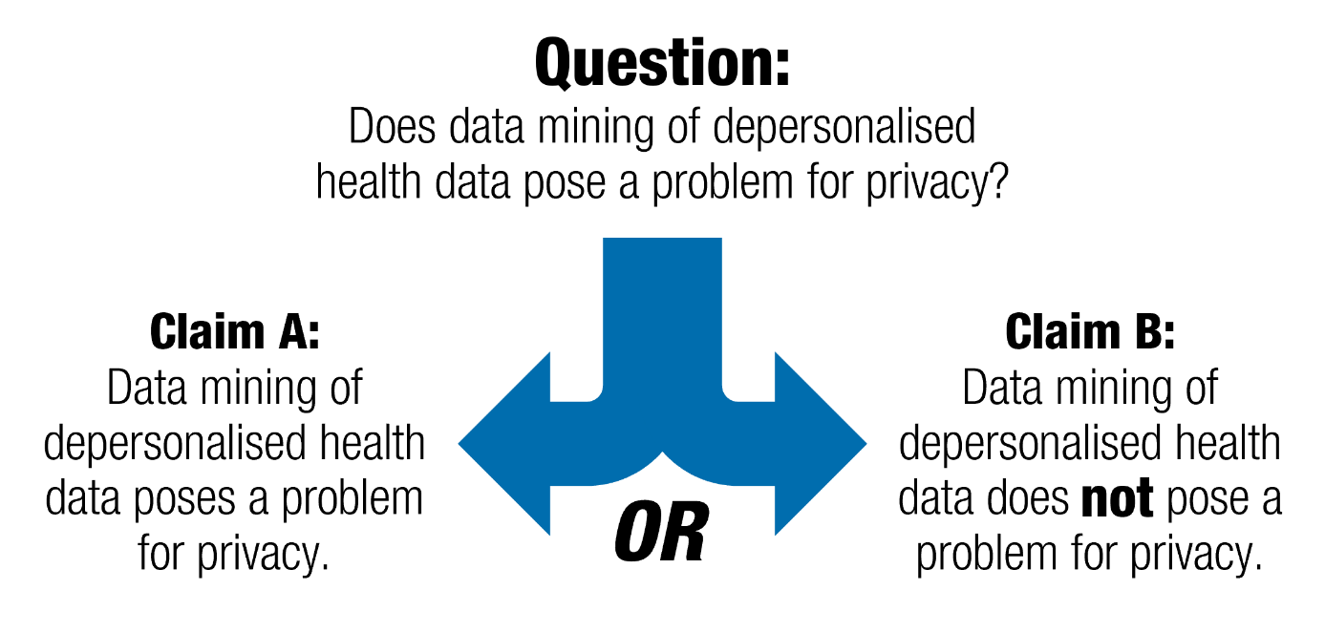

Note that in order to formulate a claim, you need to make a decision. In our example, it means choosing between claim A (data mining poses a problem) and claim B (data mining does *not* pose a problem).

## Bring together your evidence and reasoning

Evidence provides the foundation for your argument. Without credible, relevant and accurate evidence, your argument loses substance and becomes a statement of opinion. To ensure your evidence is appropriate, always question your sources.

Reasoning is the “glue” that holds your argument together. Reasons connect evidence with claims and show how you are using evidence to make your point. Without good reasoning, even strong evidence may not be enough to make a strong argument.

When using evidence to support your reasons and claims:

* ensure the evidence you choose is relevant to your argument
* ensure the evidence is appropriate for your task and discipline
* always question your sources

## Structure your argument

To make sure your argument is logical and well organised, you can create a “map” of your argument. An argument map is a visual representation of an argument.

The advantage of an argument map is that you can “see” the argument and how the different components are interconnected and support each other. An argument map can make it easier to manage information from a variety of sources and to identify key claims based on different reasons. It can help you strengthen and focus your themes and logical relationships between claims.

Ein Bild, das Text, Screenshot, Schrift, Reihe enthält.

Notes:

* The argument refers to the overall argument to which all else is directed
* Different claims work together to make your overall argument
* Reasons support your claims
* Evidence provides a foundation for all claims and counterclaims
* Counterclaims need to be considered for your argument to be balanced

## Check your understanding

1. Choose relevant evidence

The paragraph below is a summary of an argument (note especially the sentence that contains the words “demonstrates that …”). What type of evidence would be most relevant in supporting this argument?

Contests over Australian history captivate governments, historians and public commentators; they grab headlines and spawn endless public commentary. The ‘history wars’, as those debates have come to be known, play out over museum exhibits, national commemorations, public apologies and the ways we teach the past to the next generation: should the Australian War Memorial commemorate the victims of the Australian frontier wars? Should Australians be sorry for historical actions in the past? Should Australian history be compulsory in school? (And so on.) But does that ‘national story’ have any meaning for Australian families and communities? This paper canvasses some recent qualitative research into historical consciousness in Australia to explore the ways those historical discourses operate beyond the public domain. It asks participants to speak in their own words about what history means: how they relate to their local and family histories, and how they engage with Australian history more broadly. Importantly, the project reveals a depth and complexity to Australians' historical engagement and demonstrates that public and personal discourses about the past do indeed intersect in everyday life around the country (Clark, 2016).

1. What sort of evidence would be useful for this research? (Tick all that apply)

|  |  |
| --- | --- |
| X | Journal articles |
| X | Hansard (Parliament transcript) |
| X | Museum exhibits/artefacts |
|  | Australian Bureau of Statistics data |
| X | Newspaper articles |
| X | Interviews |

1. What other types of evidence can you think of?

Something like research papers.

1. Use reasoning to connect claims and evidence.



|  |  |  |
| --- | --- | --- |
| Critical thinking skills are necessary to provide safe and comprehensive nursing care given that |  | it operates to maximize profits |
| Australian business conditions are the best in two decades because |  | nurses need to deal effectively with complex change |
| The US healthcare industry is ineffectual as |  | Australia says YES to marriage equality |
| Today is a great day for human rights since |  | there has been an increase in manufacturing and sentiment is high |